Cloud basics

Navigating IBM Cloud

IBM

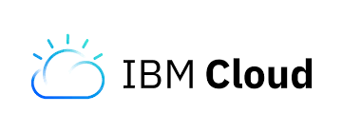

Notices and Disclaimers

© Copyright IBM Corporation 2018.

The information contained in these materials is provided for informational purposes only, and is provided AS IS without warranty of any kind, express or implied. IBM shall not be responsible for any damages arising out of the use of, or otherwise related to, these materials. Nothing contained in these materials is intended to, nor shall have the effect of, creating any warranties or representations from IBM or its suppliers or licensors, or altering the terms and conditions of the applicable license agreement governing the use of IBM software. References in these materials to IBM products, programs, or services do not imply that they will be available in all countries in which IBM operates. This information is based on current IBM product plans and strategy, which are subject to change by IBM without notice. Product release dates and/or capabilities referenced in these materials may change at any time at IBM’s sole discretion based on market opportunities or other factors, and are not intended to be a commitment to future product or feature availability in any way.

This document is current as of the initial date of publication and may be changed by IBM at any time. Not all offerings are available in every country in which IBM operates.

IBM, the IBM logo and ibm.com are trademarks or registered trademarks of International Business Machines Corporation in the United States, other countries, or both. If these and other IBM trademarked terms are marked on their first occurrence in this information with a trademark symbol (® or ™), these symbols indicate U.S. registered or common law trademarks owned by IBM at the time this information was published. Such trademarks may also be registered or common law trademarks in other countries. A current list of IBM trademarks is available on the Web at “Copyright and trademark information” at ibm.com/legal/copytrade.shtml

Other company, product and service names may be trademarks or service marks of others

Table of Contents

Prerequisites 4

Purpose of this Lab 4

Part 1: Signing up for IBM Cloud 5

Part 2: Navigating the IBM Cloud Platform 7

Part 3: Launching a Watson Service 11

Part 4: Deploy a Cloud Foundry app using the Node-RED Starter Boilerplate 16

Part 5: Deploying an Application to the Cloud using Continuous Delivery 26

Conclusion 30

**An Introduction to Cloud and IBM Cloud Platform**

# Prerequisites

None

# Purpose of this Lab

The purpose of this lab is to introduce the IBM Cloud Platform.

By the end of this lab, you will be have:

* A basic understanding of Cloud
* An understanding of and the ability to navigate the IBM Cloud Platform
* The ability to launch and use services on IBM Cloud

# Part 1: Signing up for IBM Cloud

We are going to sign up for a free IBM Cloud account.

Go to <https://www.ibm.com/cloud/>

­­­

Click “Sign up”.

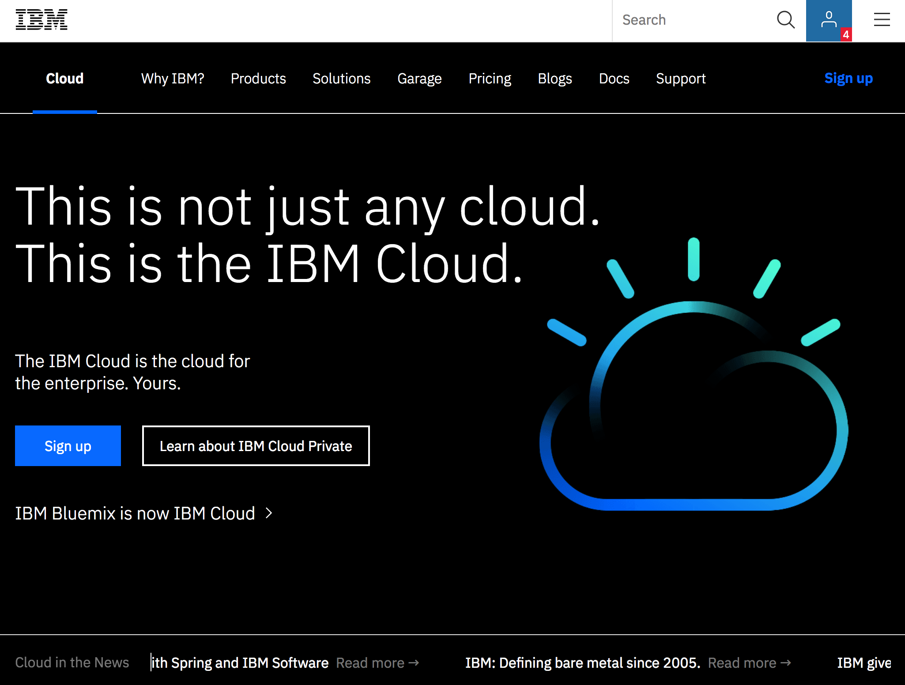

Fill in the required boxes.

Click “Create Account”.

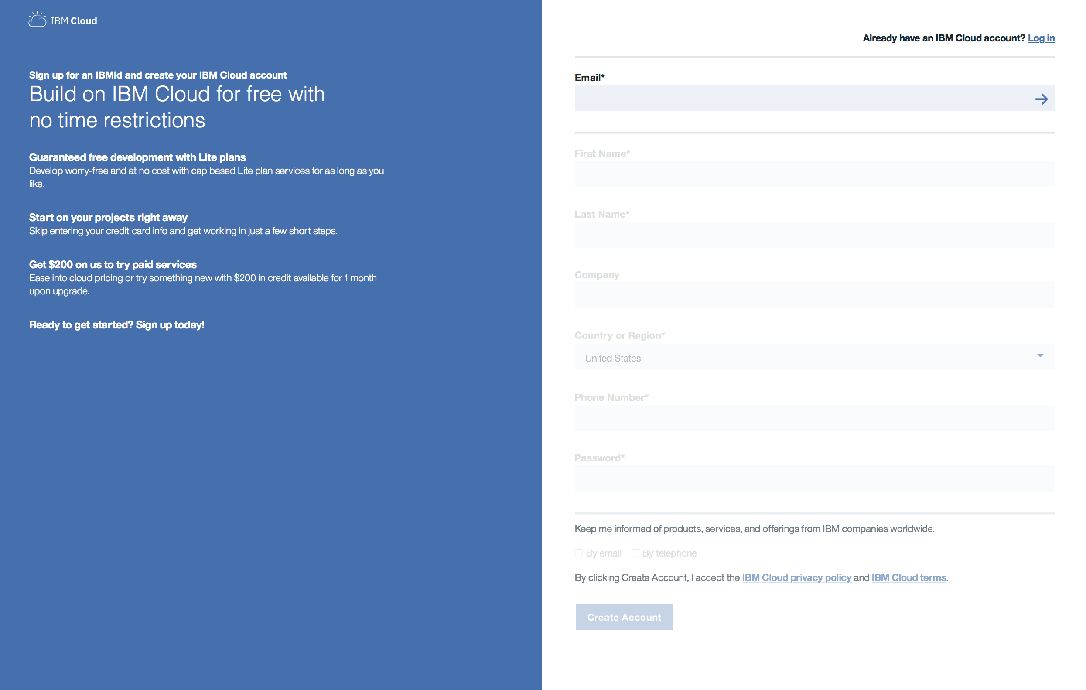

# Part 2: Navigating the IBM Cloud Platform

Log into IBM Cloud at [https://console.bluemix.net/](https://console.bluemix.net/dashboard/apps/)

If this is the first time you are using IBM Cloud (formerly Bluemix), an introduction window will appear, feel free to read it. Otherwise, click through. Click “Next”, then click “Finish”.

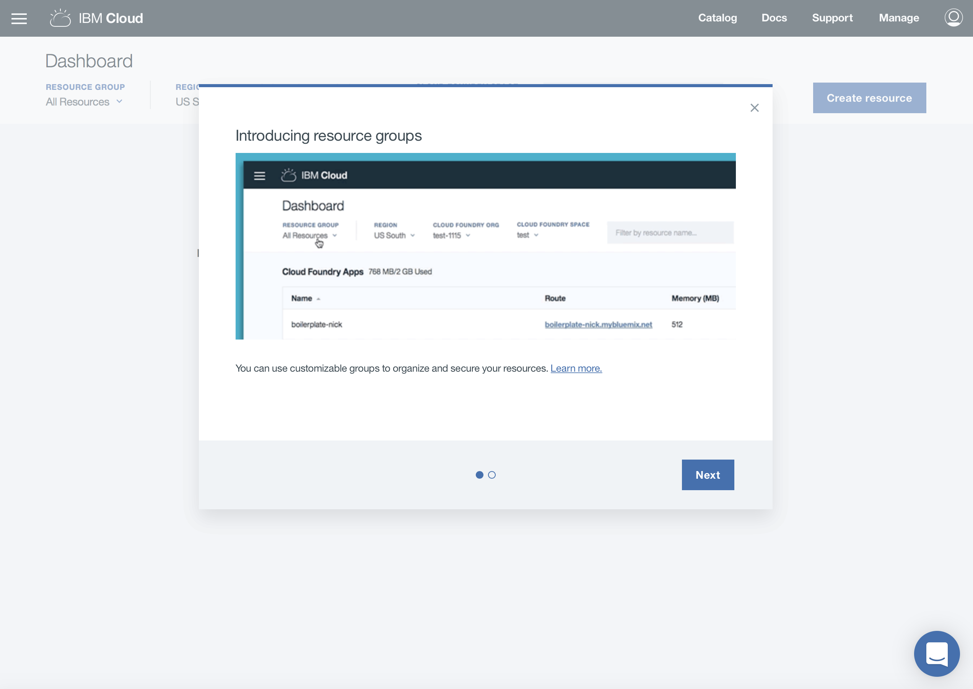

We are now looking at the IBM Cloud Dashboard.

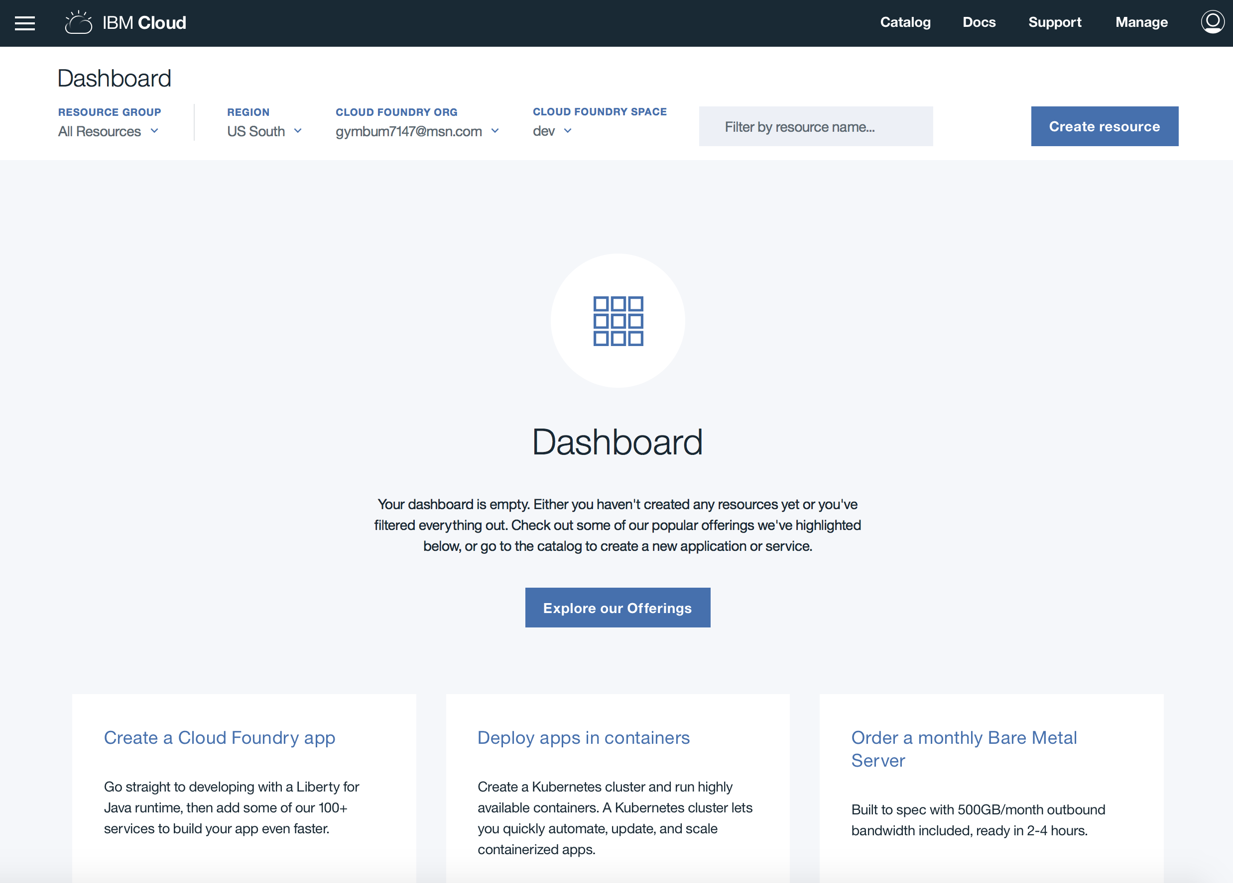

Click on the “Catalog” button found in the upper right hand corner of the screen.

The Catalog is a compilation of the services offered on the IBM Cloud.

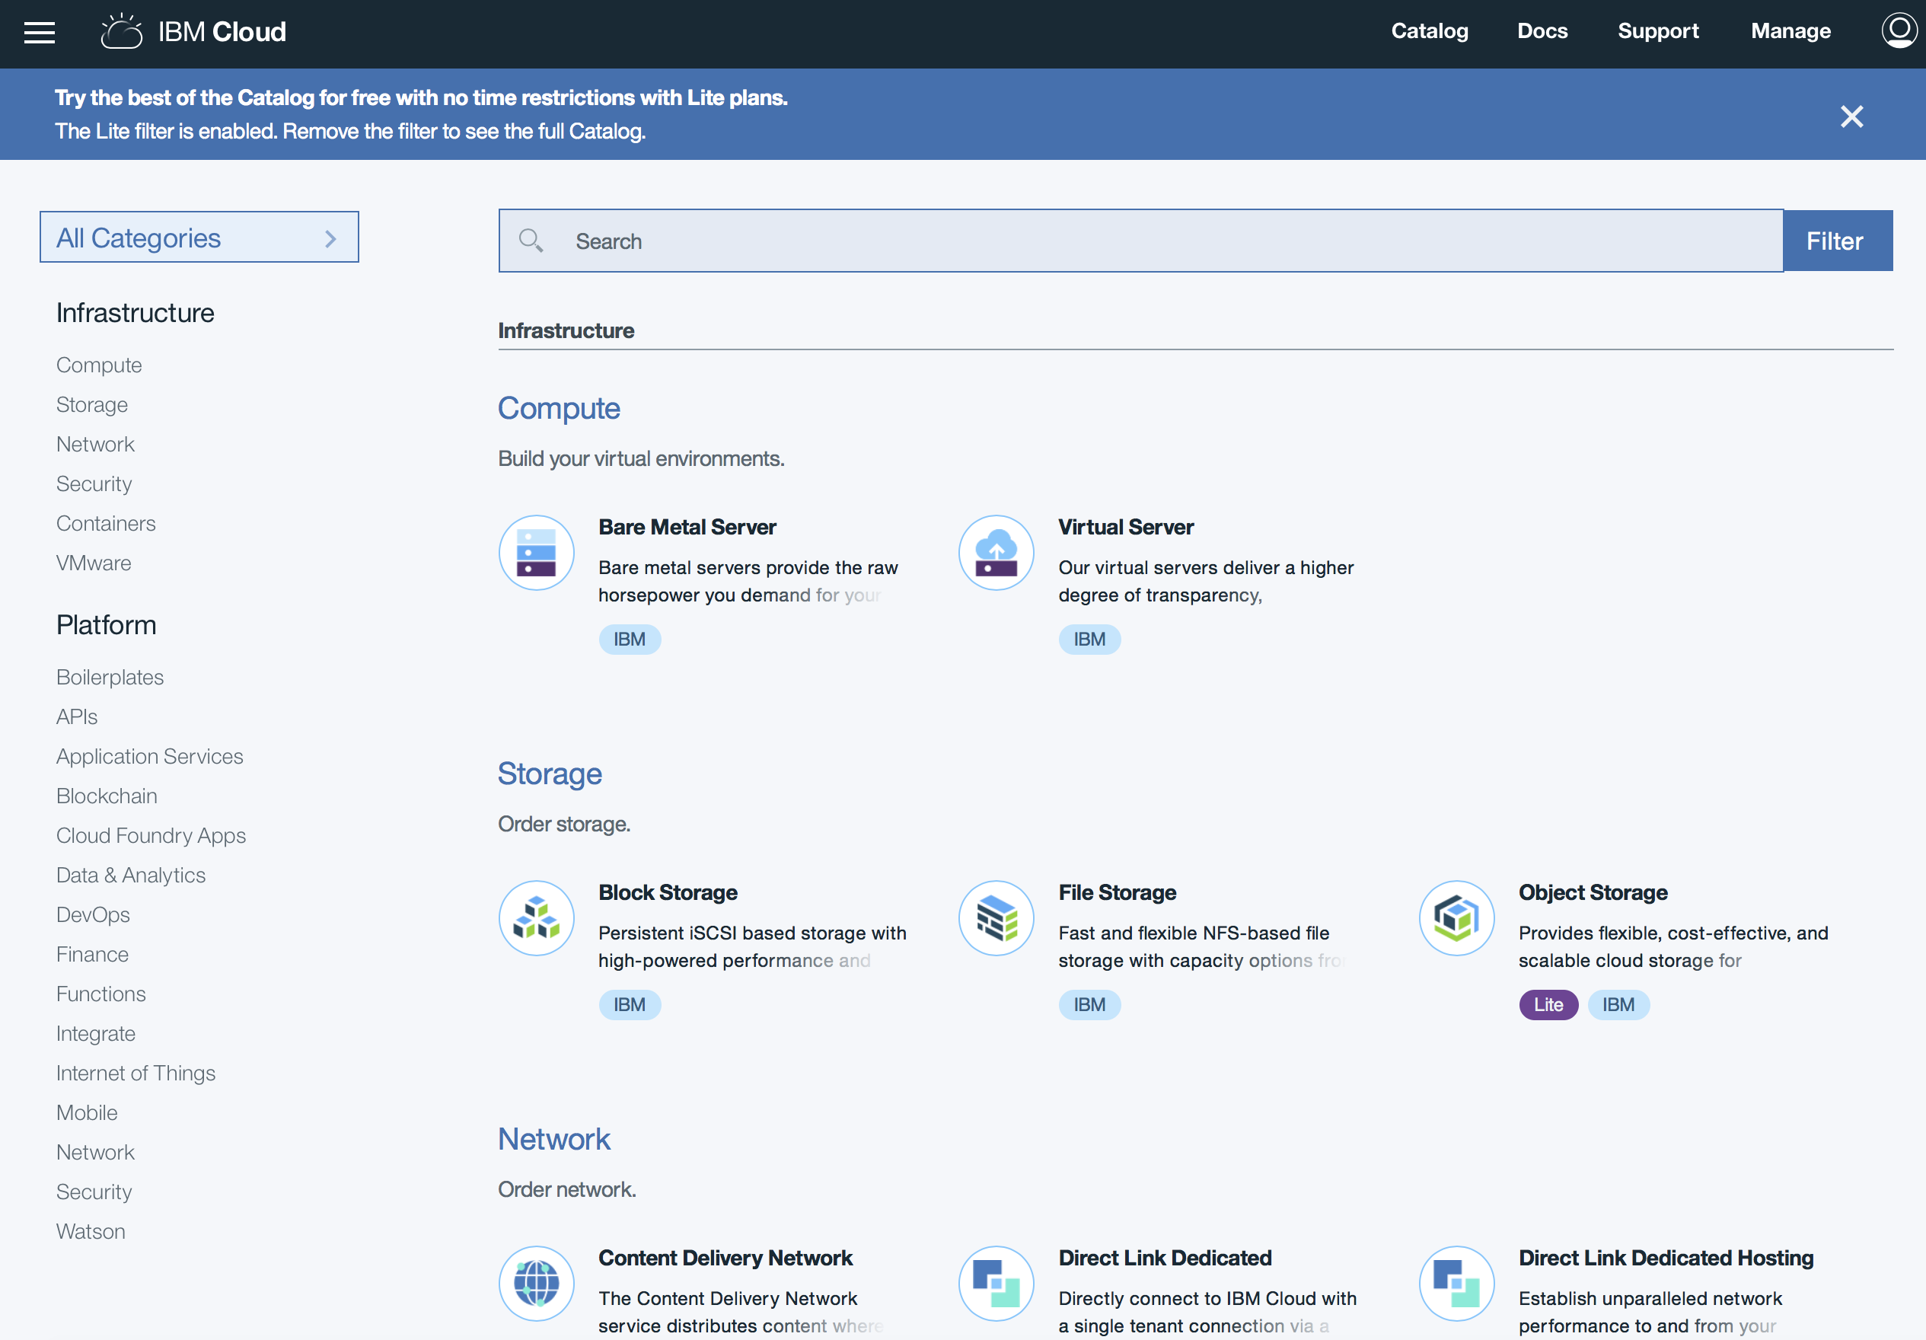

IBM Cloud supports a broad range of cloud services and capabilities from IBM, open source communities and third-party developers. These are indicated by the small colored ovals below each service description.

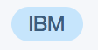  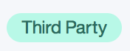

This is the navigation bar.



The **Docs** link provides details on each of the services. This is the first “go to” resource if you have questions about any of the services. IBM Cloud Docs houses tutorials, demos, videos, starter kits…if you have questions about a service, this is a great resource

The **Support** page is available to answer any questions that cannot be found in Docs.

And lastly **Manage** is where you can manage your account Space and Organization. You can have multiple Spaces. This is a way to keep different projects organized.

Click on “Docs”.

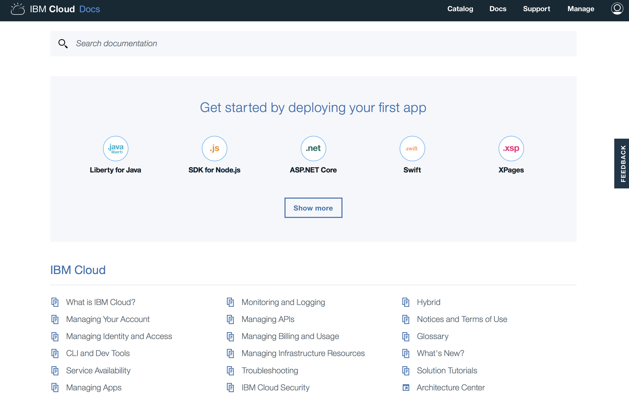

Click on “Support”.

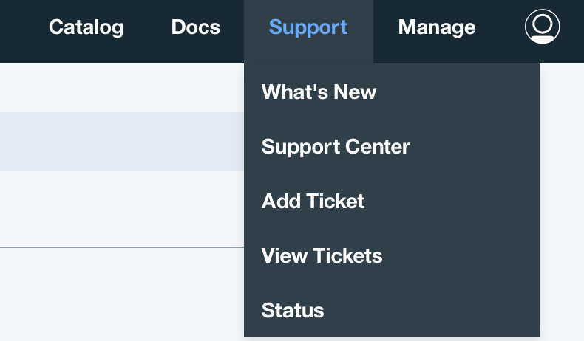

Click on “Manage”.

Click on the head icon.



# Part 3: Launching a Watson Service

Let’s create our own service.

Click on “Catalog”.

Type into the search bar: “Personality Insights”.

Alternative way: In the Categories sections, select Watson, then Personality Insights.

Click on “Personality Insights” under the Watson section.

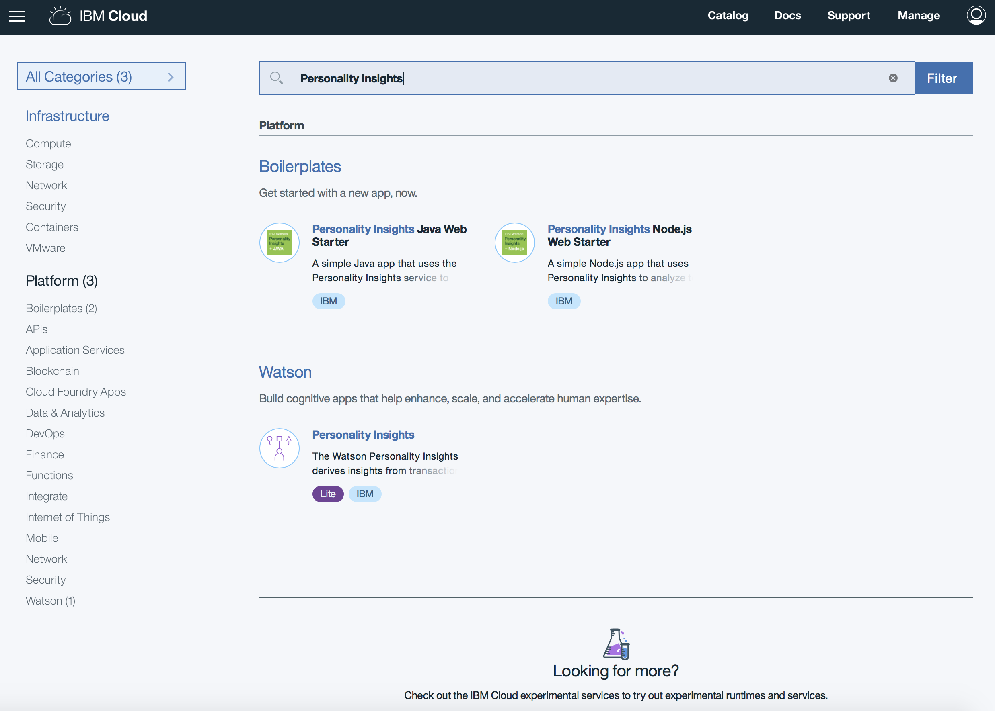

Watson Personality Insights predicts personality characteristics, needs and values through written text. Understand your customers’ habits and preferences on an individual level, and at scale. We see it used quite frequently to dictate customer interactions based on their preferences. Subscription services and experiences can be catered to customer personality as can offers or even the approach a sales person may take when approaching a customer.

Type a Service name of your choice. This will be added to a list of your deployed services, and that list will grow, so it is helpful to use a descriptive title including a reference to the project it will be used for. (Ex. Visual Recognition for Flower Classification)

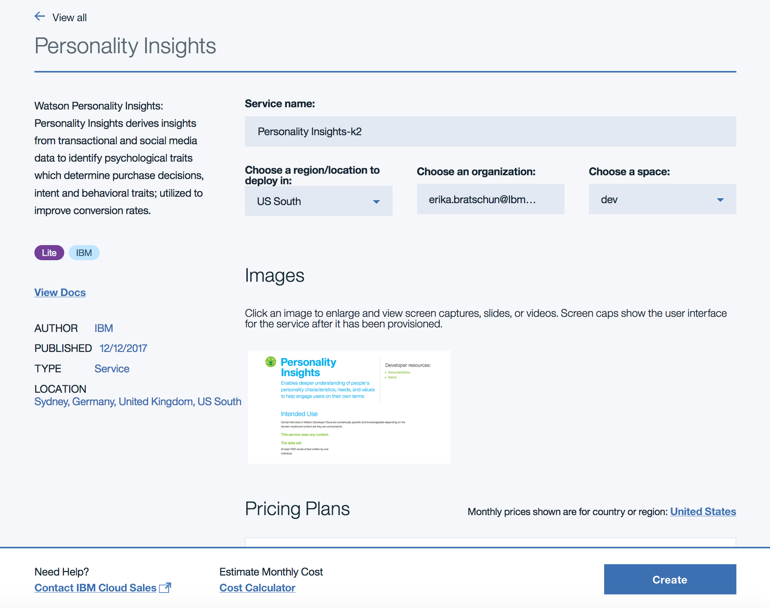

The “Lite” plan is selected by default.

Select “Create” to deploy the Personality Insights Service.

This page indicates that the service had been created.

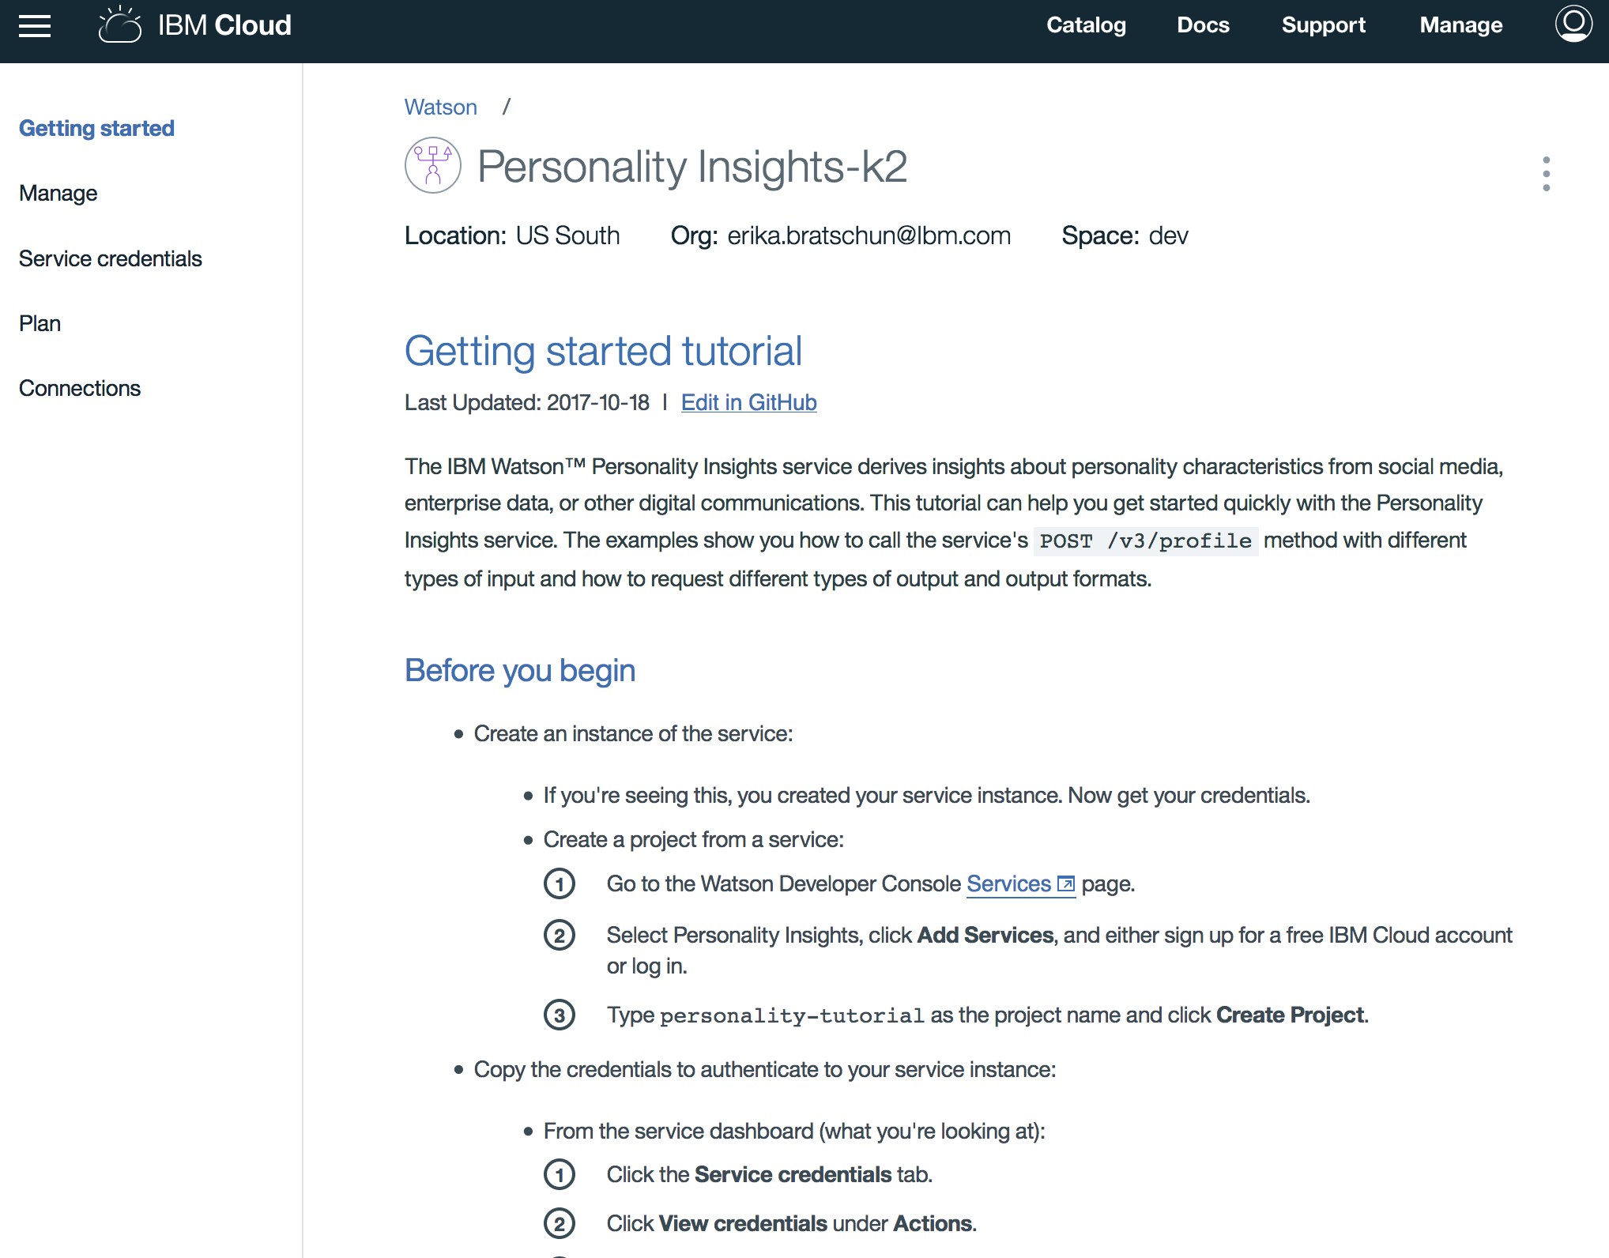

Click on “Manage”.

Click on “Demo”.

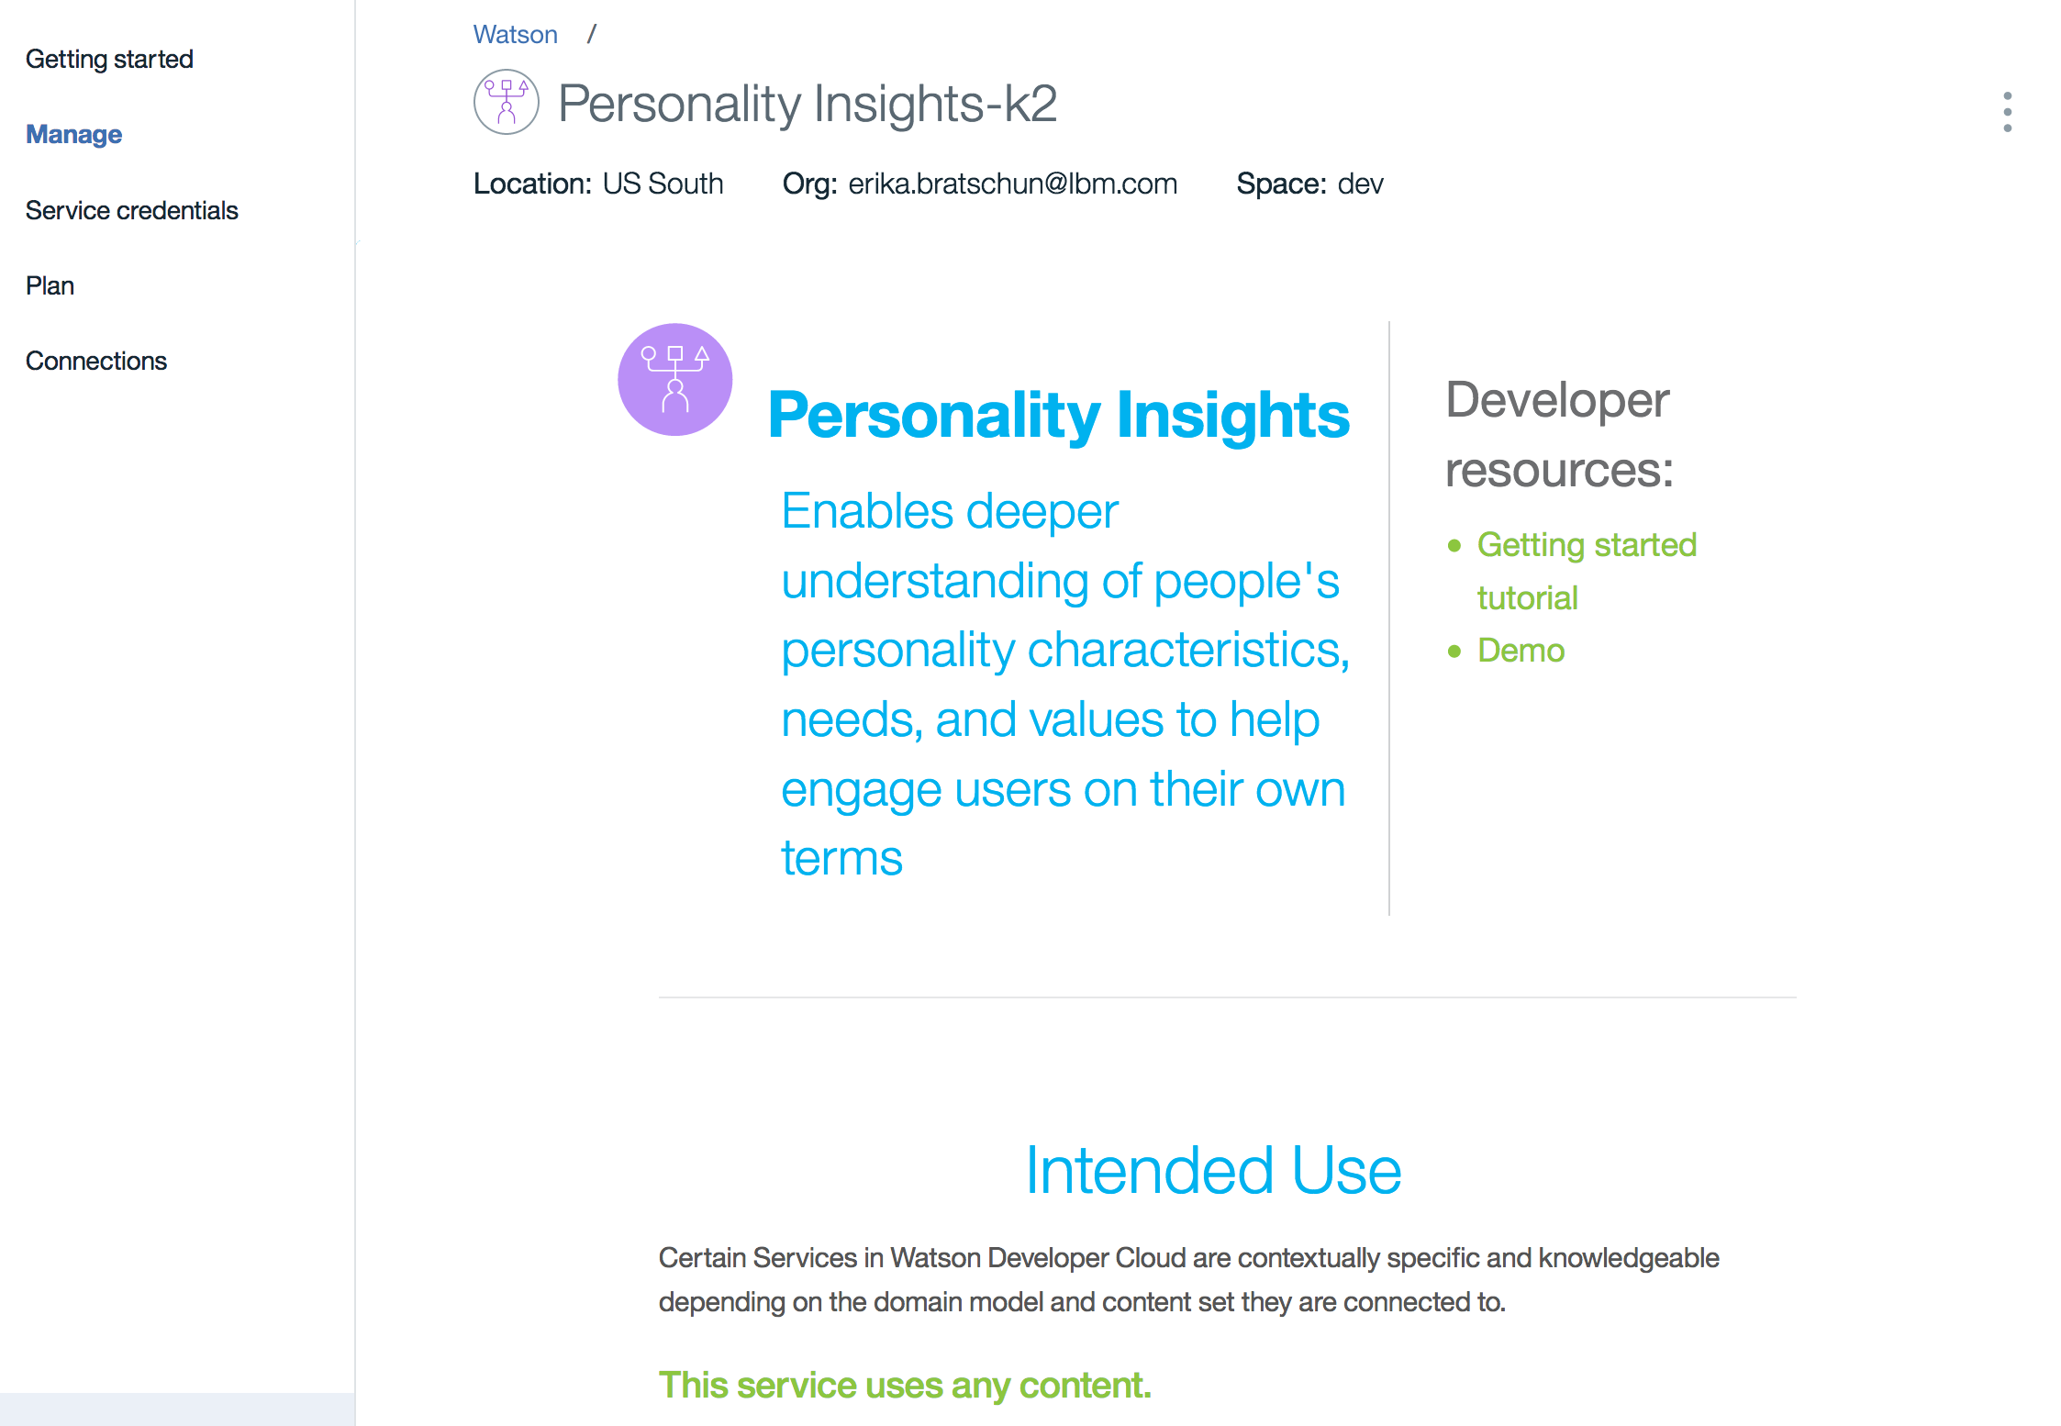

The default demo offers a few twitter handles to analyze their personalities based on tweets. You can also put in your own handle if you’d like. Other options include body of text.

Click on one of the Twitter handles. (@faridyu is used below)

Click “Analyze”.

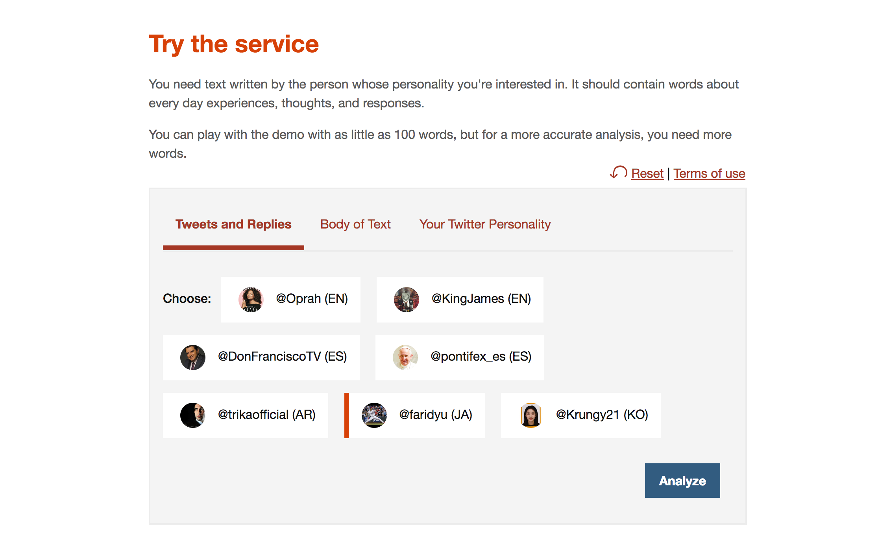

Scroll down to the output.

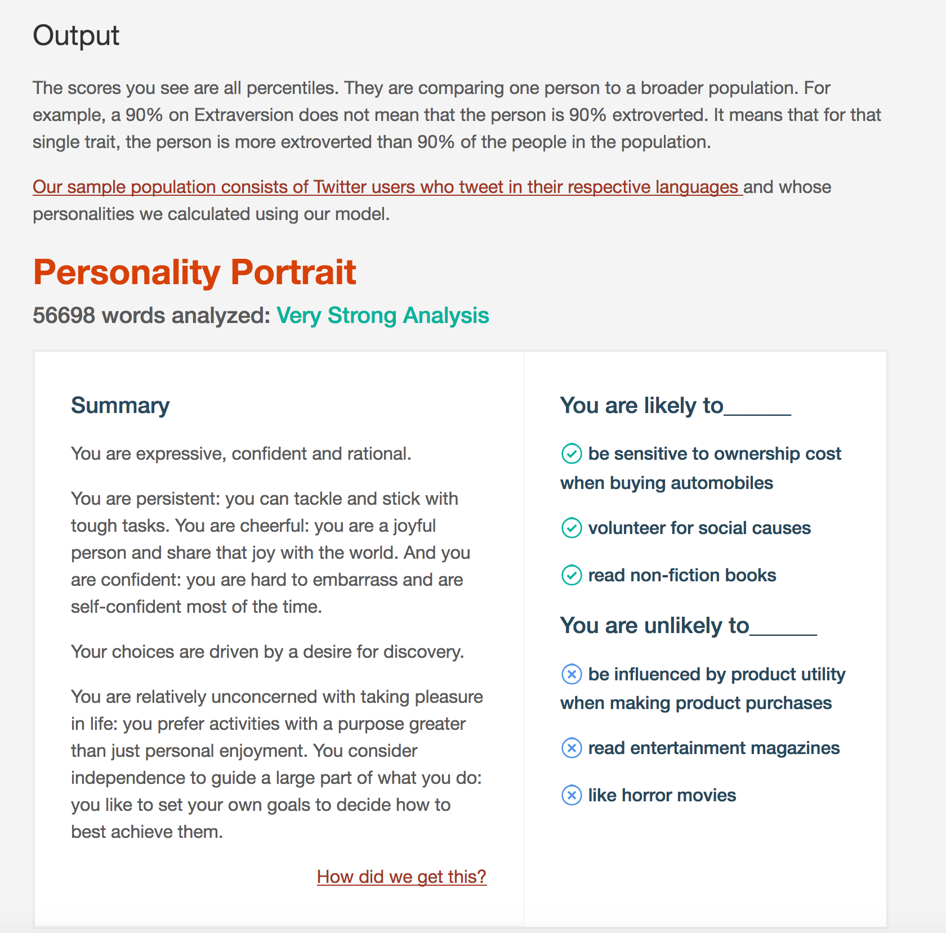

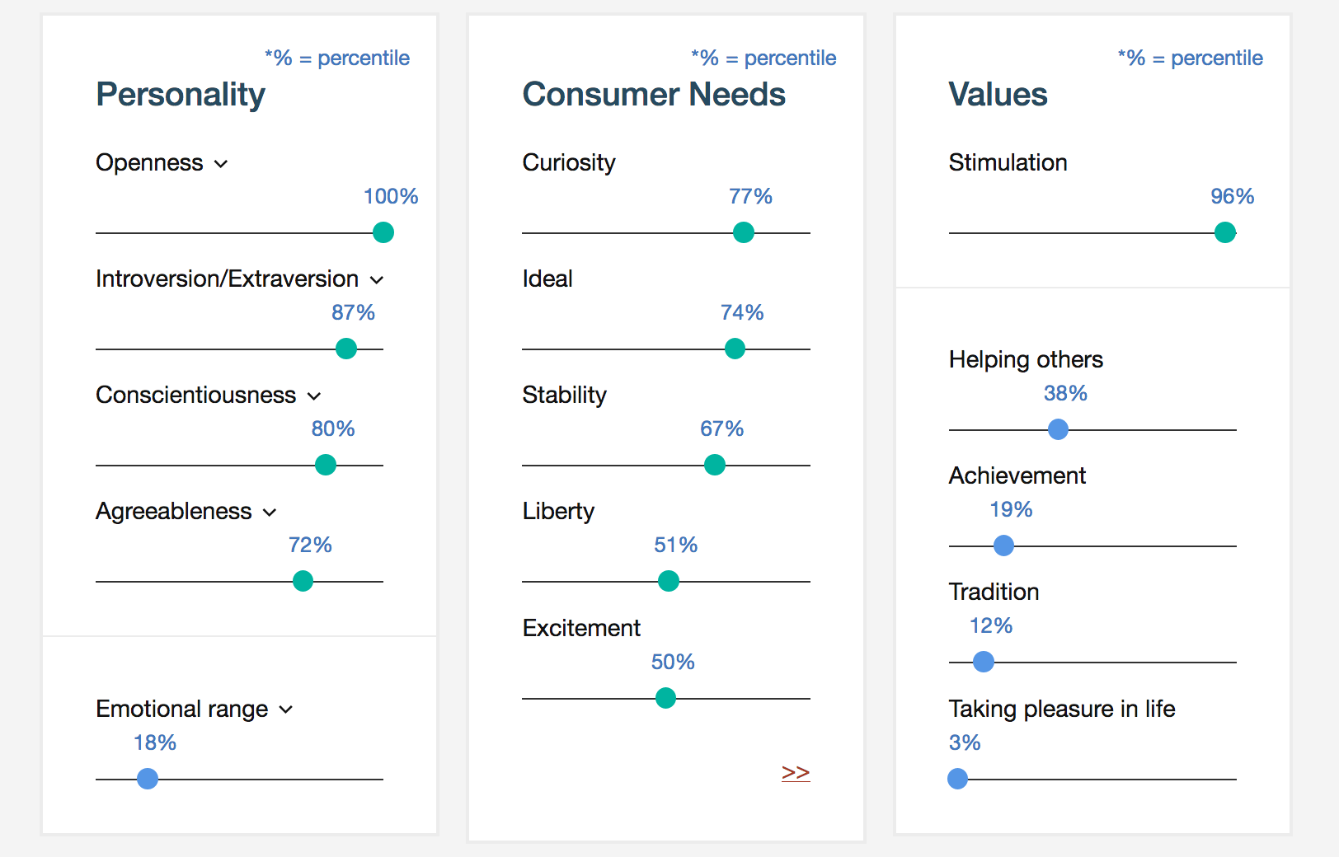

# Part 4: Deploy a Cloud Foundry app using the Node-RED Starter Boilerplate

Before we create the Node-RED Starter app we will provision a service to be used within Node-RED.

Go to the Catalog and in the search bar type “Tone Analyzer”.

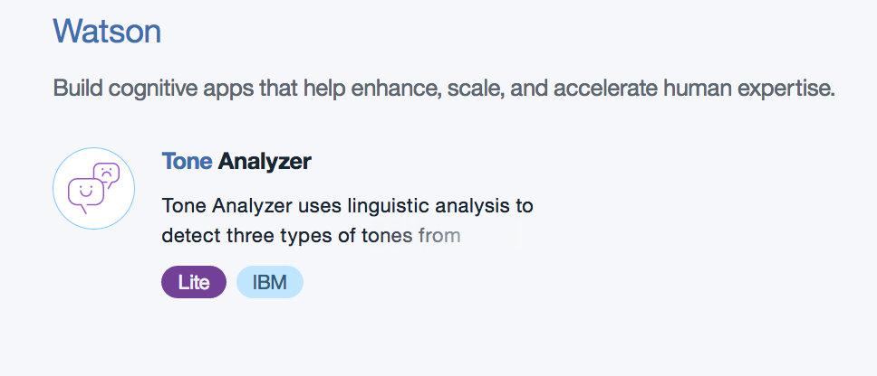

Click on Tone Analyzer.

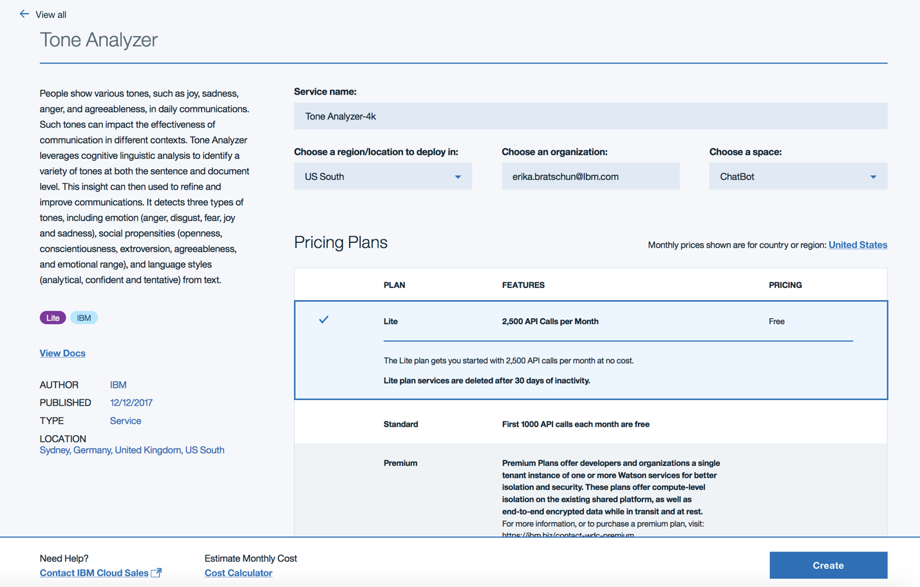

Click “Create”.

Now we will create our **Node-RED Starter** app.

Return to the Catalog, and in the search bar, type “Node-Red”.

Node-RED Starter falls under the Boilerplates section of the catalog.

Node-RED Starter provides a flow editor to make it easy to wire devices together, APIS, and online services using the wide range of nodes available in the palette. The boilerplate provided offers a quick start to application development.

Click on “Node-RED Starter”.

Fill in the required categories (once you type in an app name, it automatically becomes the host name as well).

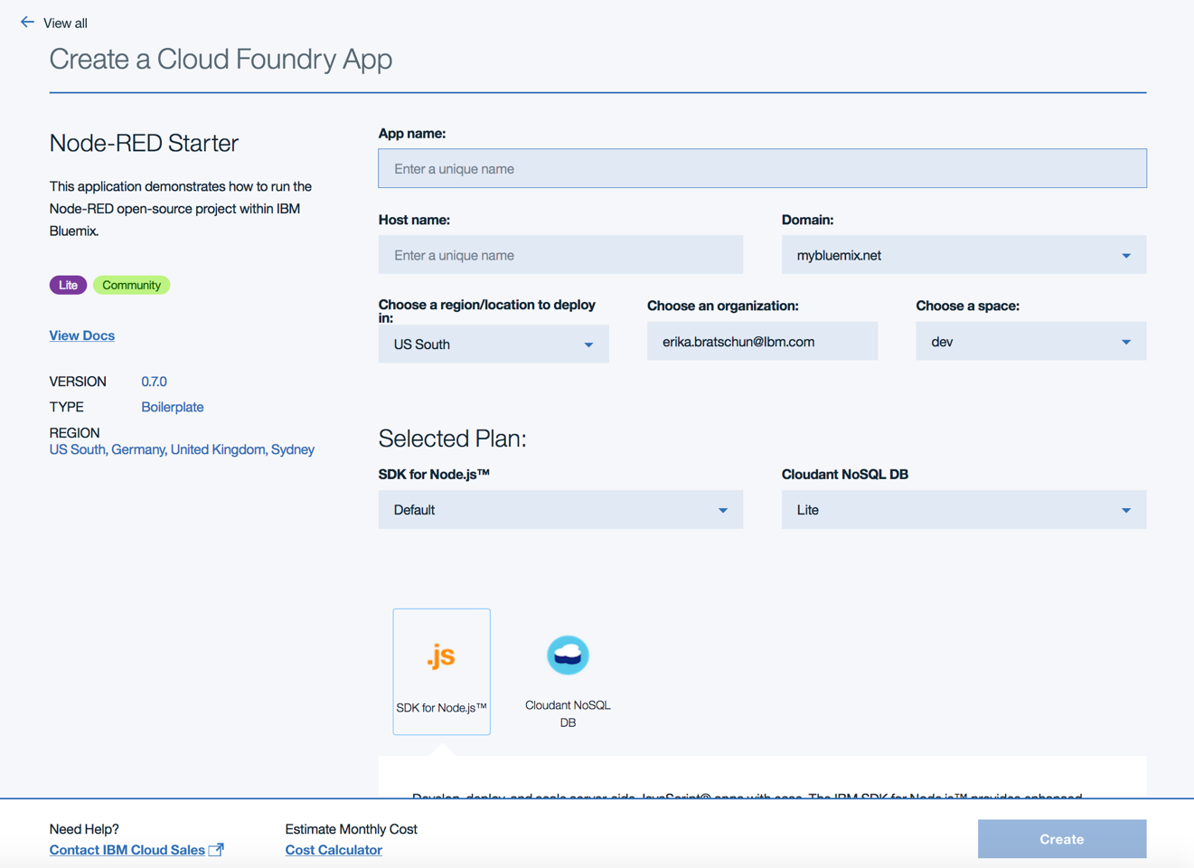

Click “Create”.

The app will take a few minutes to start, as indicated by the icon next to the apps name.

Before we can add service to the flow, we need to make sure they are connected.

Click “Connections”.

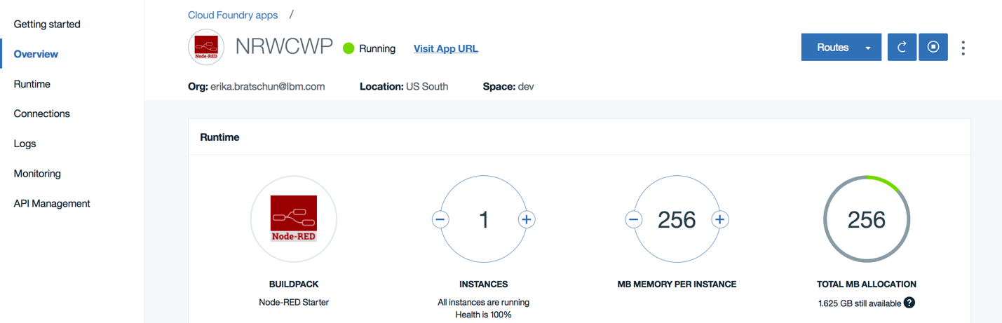

Click “Create Connection”.

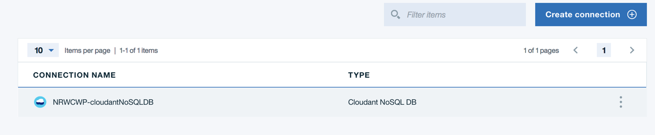

A list of all your running application that can be connected will appear.

Hover over Tone Analyzer and click “Connect”.

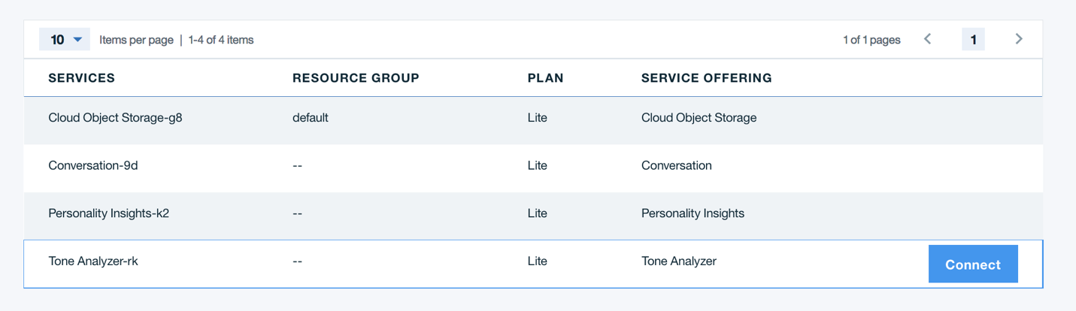

If a message pops up that asks you to restage app, click “Restage”.

Click “Visit App URL”.

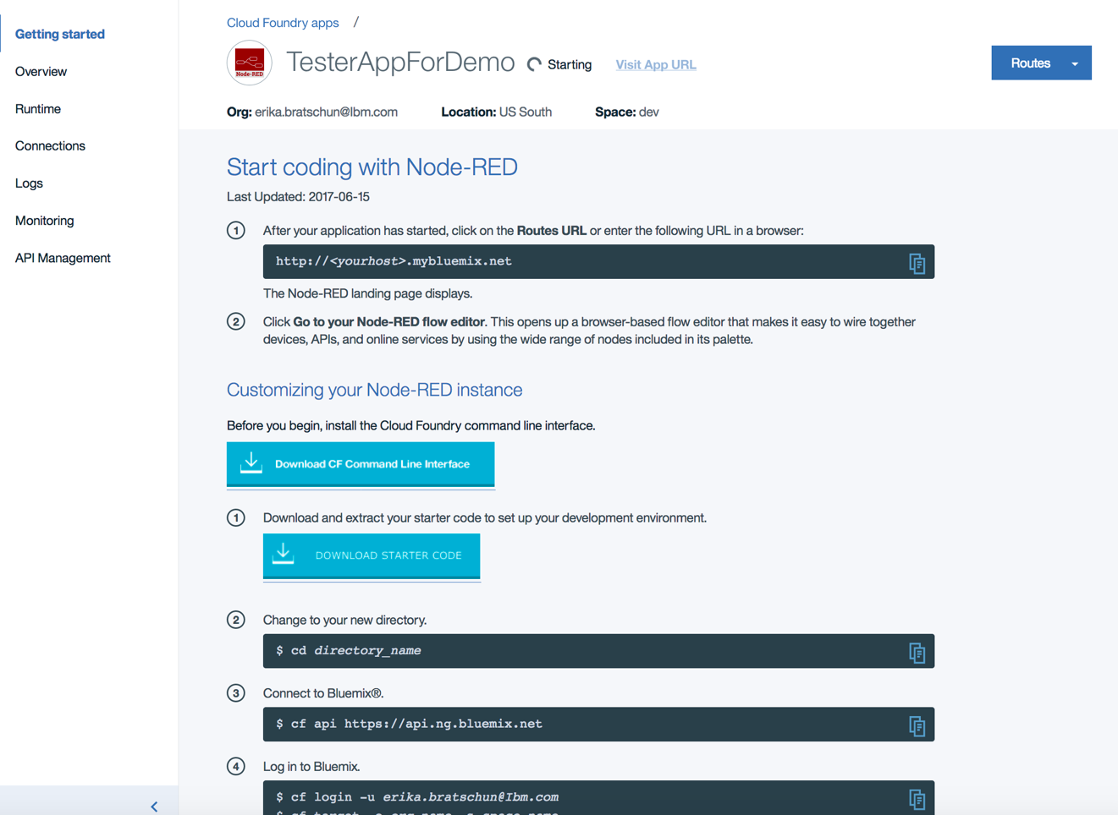

When you open your Node-RED app for the first time you will be prompted with options to secure the editor, etc. This username and password are completely independent of anything else. You will have to create them. Click “Next” through the screens then click “Finish”.

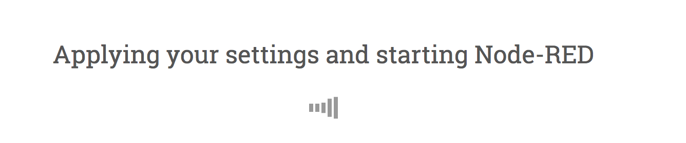

Click on “Go to your Node-RED flow editor”.

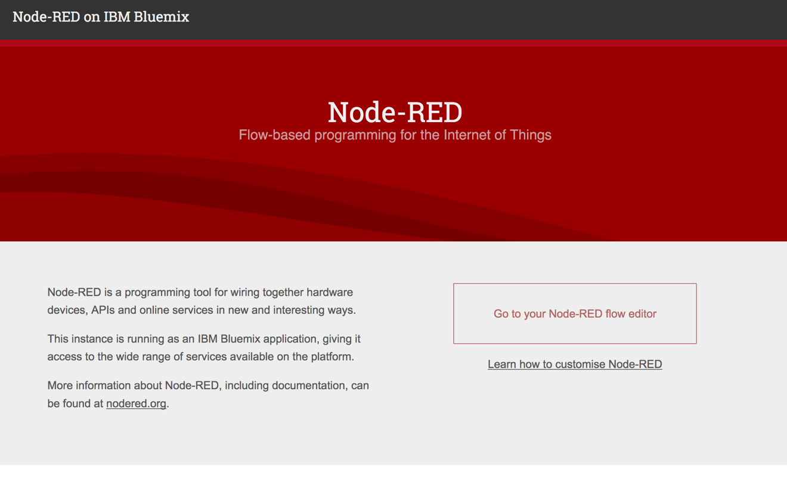

If you secured the editor with a username and password you will be brought to the login screen.

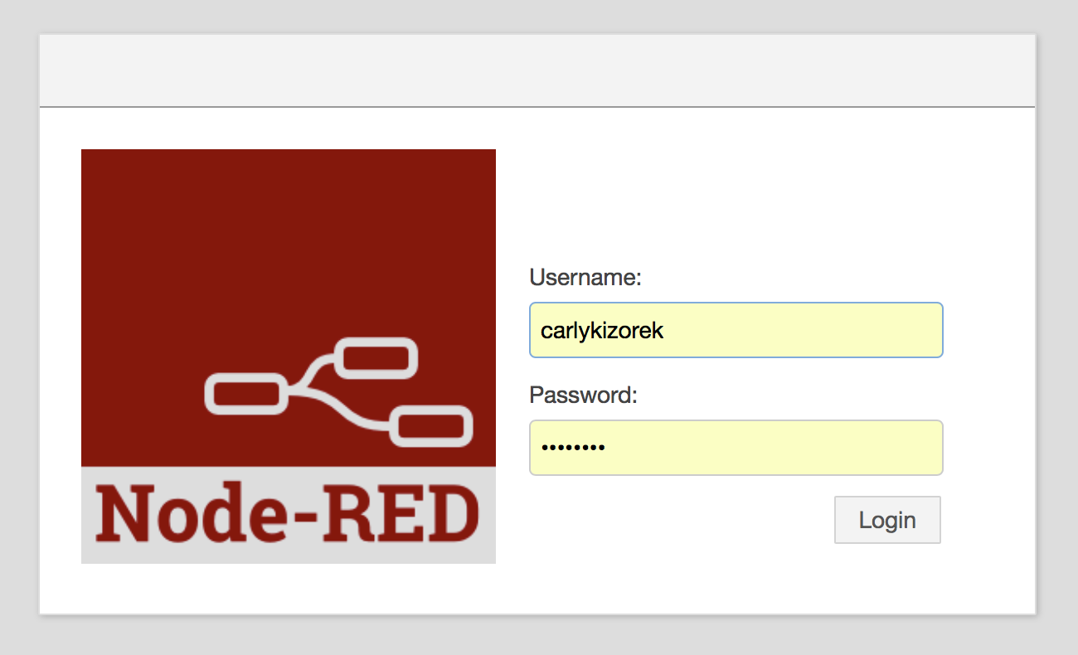

When you open the flow, you can see on the left all the nodes available in the palette that can contribute to a flow.

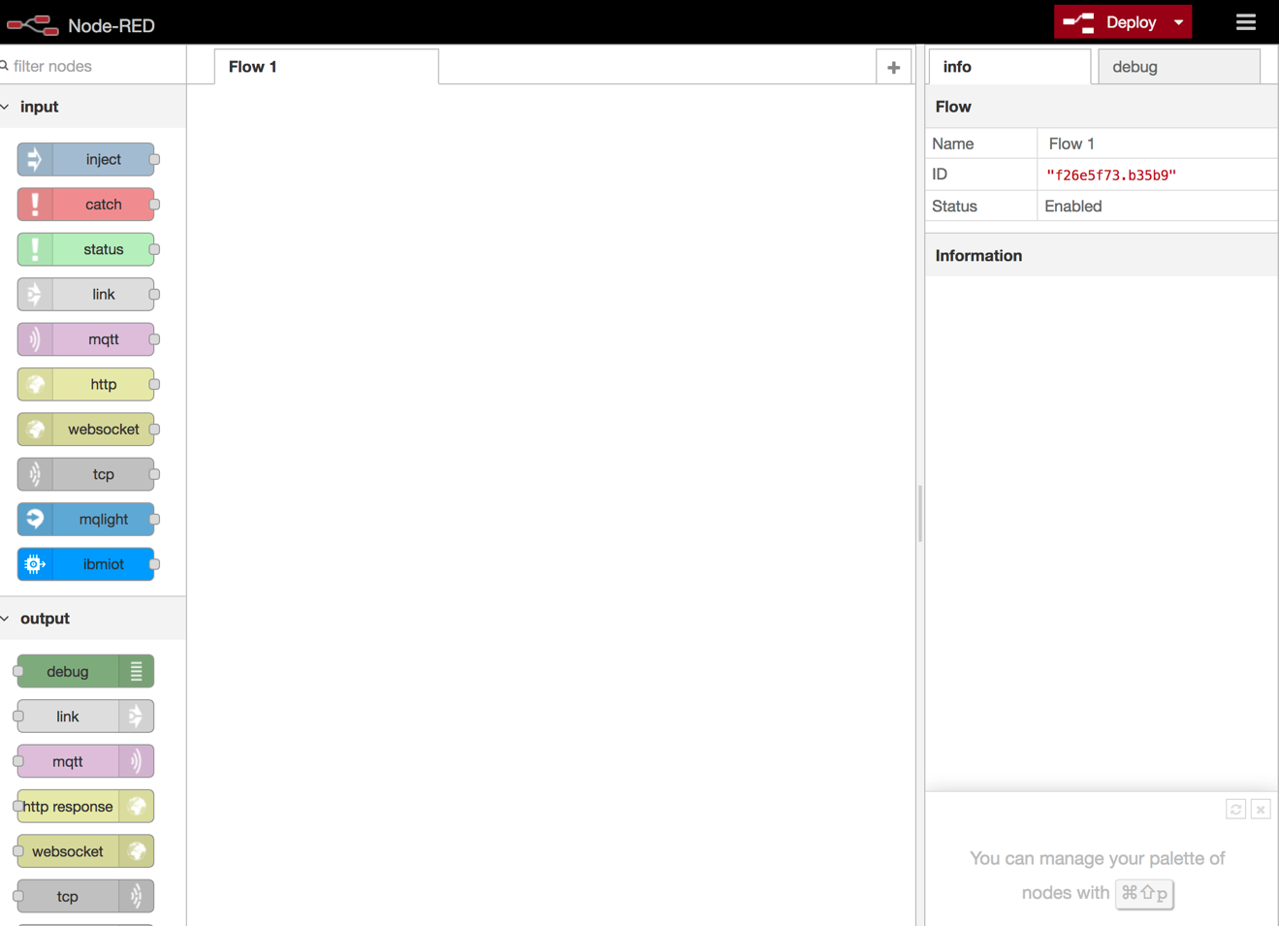

From the palette on the left drag-and-drop the following three nodes onto the canvas: “twitter” in (social category)l, “tone analyzer v3” (IBM Watson category), and debug (output category).

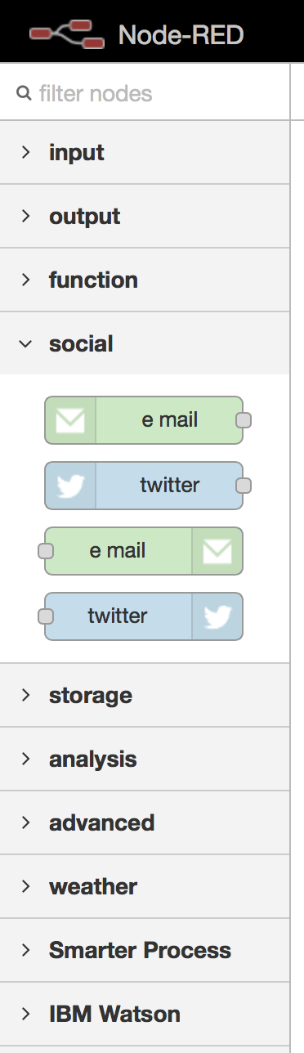 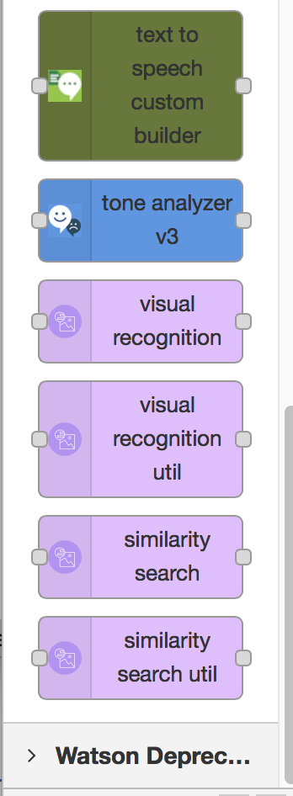 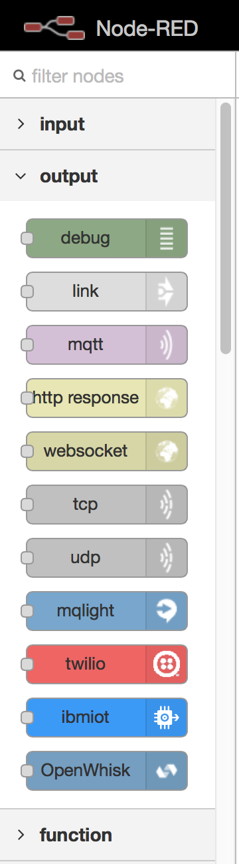

This is what your flow should look like.

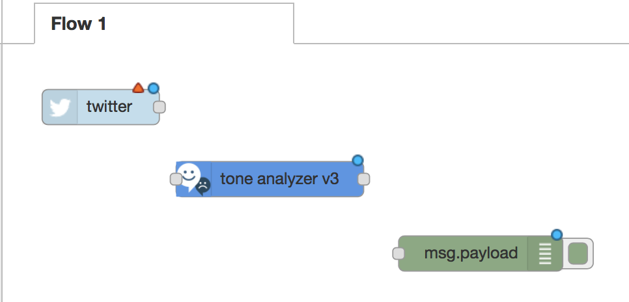

Double click the twitter node. Add your twitter credentials by clicking the pencil icon to the right of Twitter ID field.

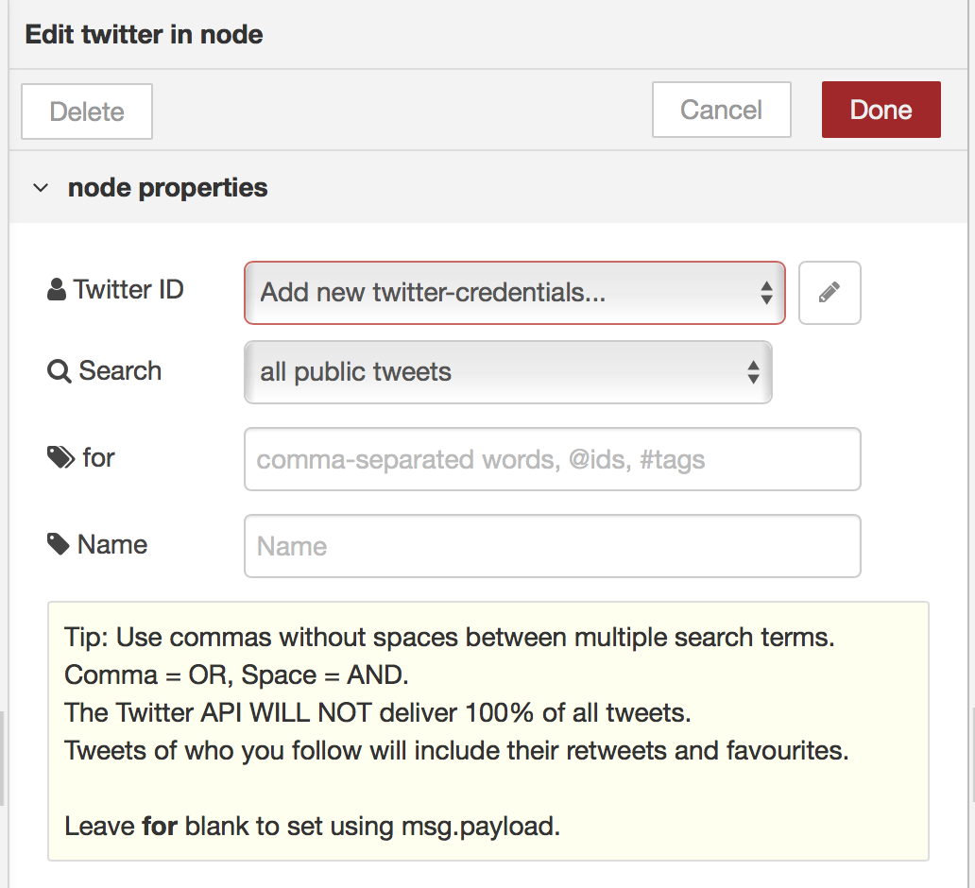

Once you click that you will prompted with this screen. Click “Click here to authenticate with Twitter”

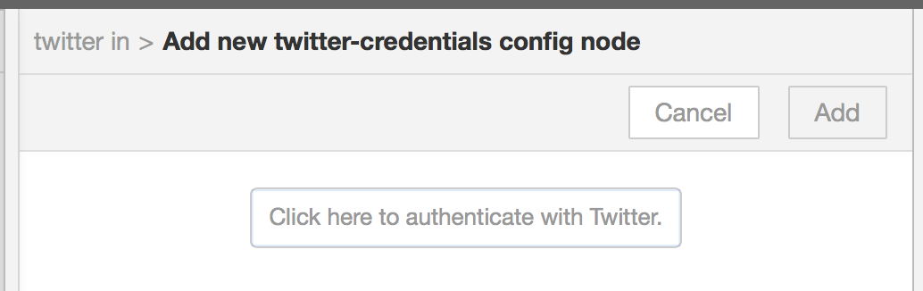

You will be redirected to Twitter to confirm the authorization:

Open a new tab in your browser and return to Tone Analyzer in IBM Cloud.

Click “Connections”.

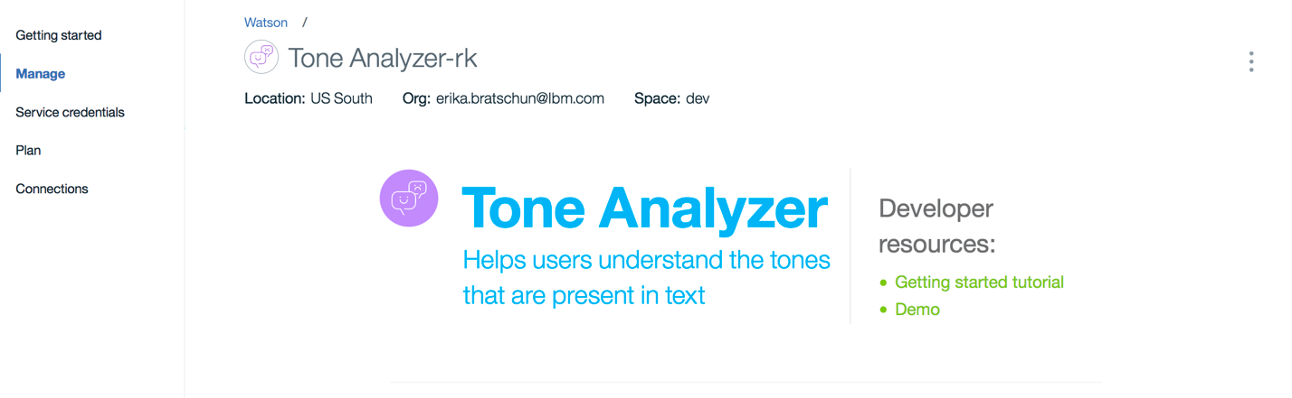

Click “Create Connection”.

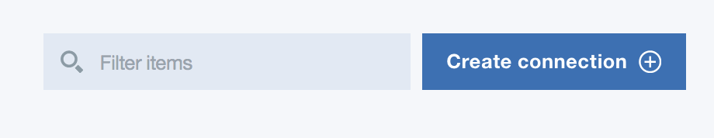

Select your Cloud Foundry application (Node.js generated from Node-Red) and click “Connect”. Your application will now show up as a connected application

Return to Node-RED flow.

Double click on the **Tone Analyzer** node.

Make your selections for each of the properties match those in the photo below.

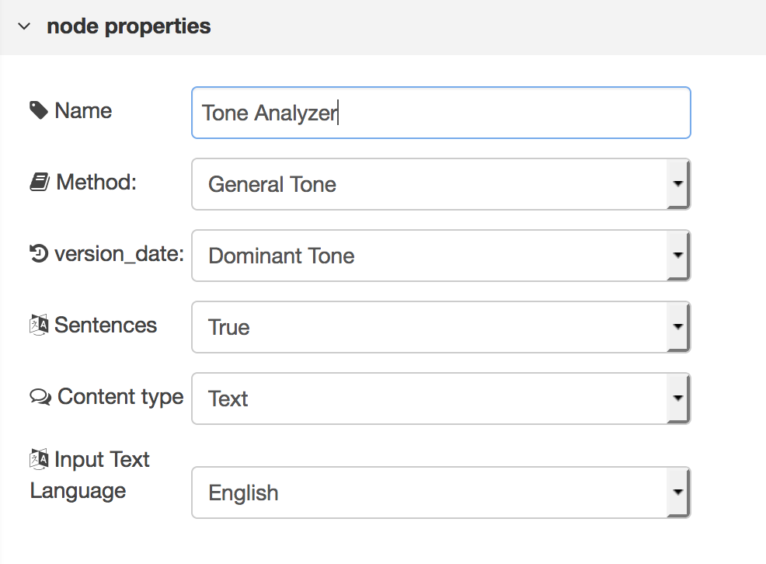

Before exiting the Tone Analyzer, click on “Port Labels”, and copy “version=2016-05-19” into Inputs

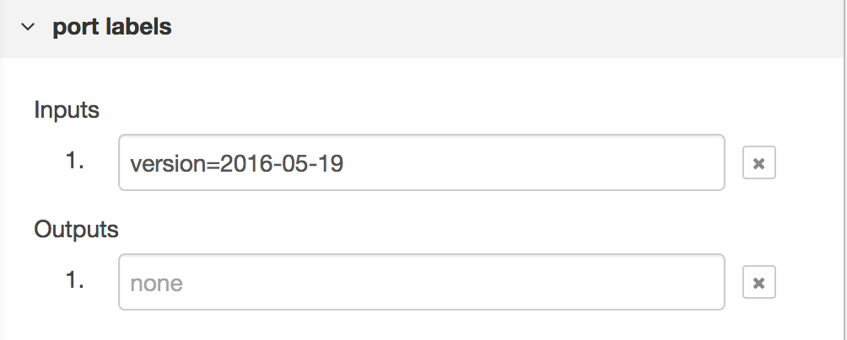

Now click “Done”.

Double click on the **debug node**

Change the Output to “complete msg object”.

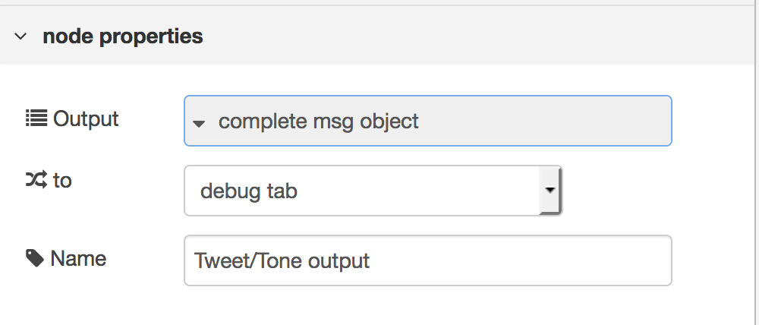

Click “Done”

Connect the nodes by clicking on the dots and drag it to the input/output of the other.

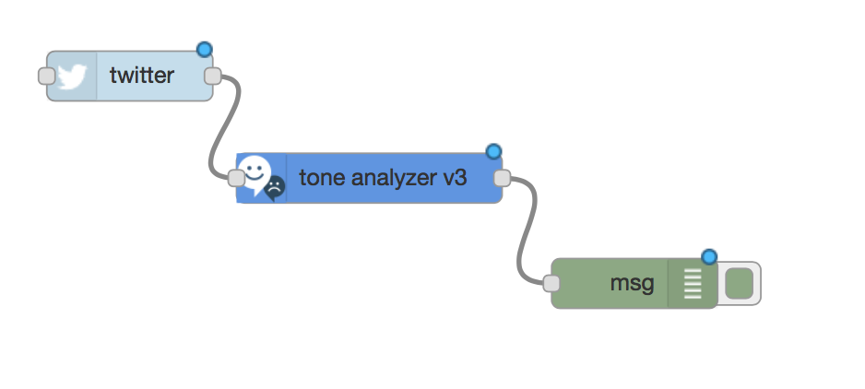

Click “Deploy” in the top right corner.

To view the output, click the debug tab, found right under the deploy button.

Tweets will begin to filter in based on the tag indicated in the twitter node. These tweets are coming in live, so as the tag is mentioned, the tweet will filter into the debug section.

To view the tweet and tone, click on one of the tweets and follow the arrow flow shown in the example below

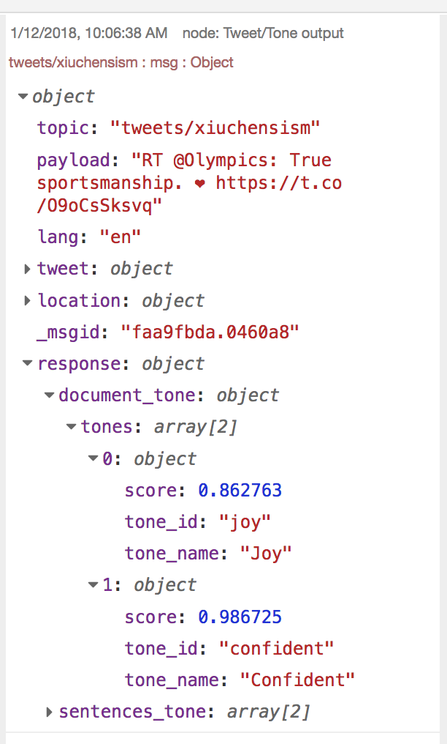

Depending on the tweet, you can see that this example shows 2 tones: joy and confidence.

Test out the tone analyzer with other tags!!

# Part 5: Deploying an Application to the Cloud using Continuous Delivery

In this example, you will deploy a Node.js application in an existing GitHub repository to the IBM Cloud. This repository has a **Deploy to IBM Cloud** button that automatically creates a Continuous Delivery toolchain, forks a copy of the application to your own code repository, and runs the Delivery Pipeline in the toolchain to deploy the application.

1. Open the sample application GitHub repository at <http://bit.ly/2EyeUXh>.
2. Scroll down to the Readme and click the  button.

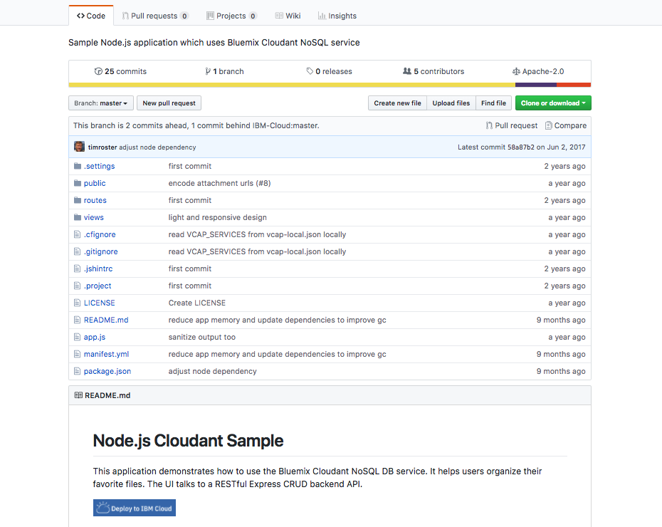

1. The toolchain creation page for your new application is shown. On this page, the tool integrations are shown. The Delivery Pipeline tool is selected, and you can update the proposed name, deployment region, organization, and space for the app or accept the defaults. For our example, just accept the defaults.

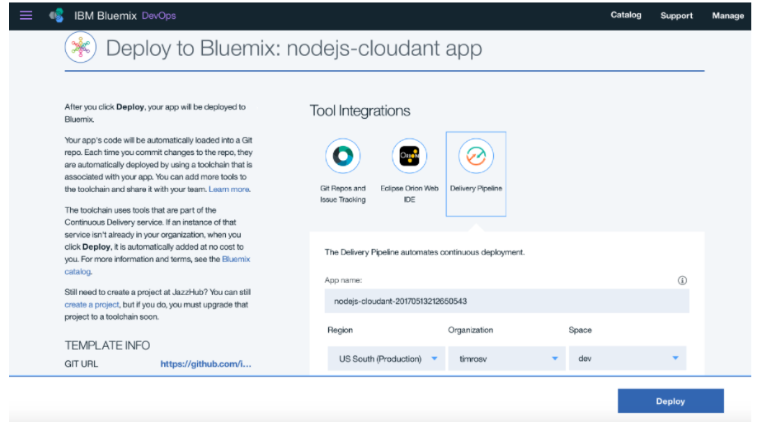

1. Under “Tool Integrations” select the icon for **Git Repos and Issue Tracking**. You see a page where you can customize the repository settings for the copy of your application source code. You can leave the default values. This repository is hosted on IBM Cloud using GitLab Community Edition.

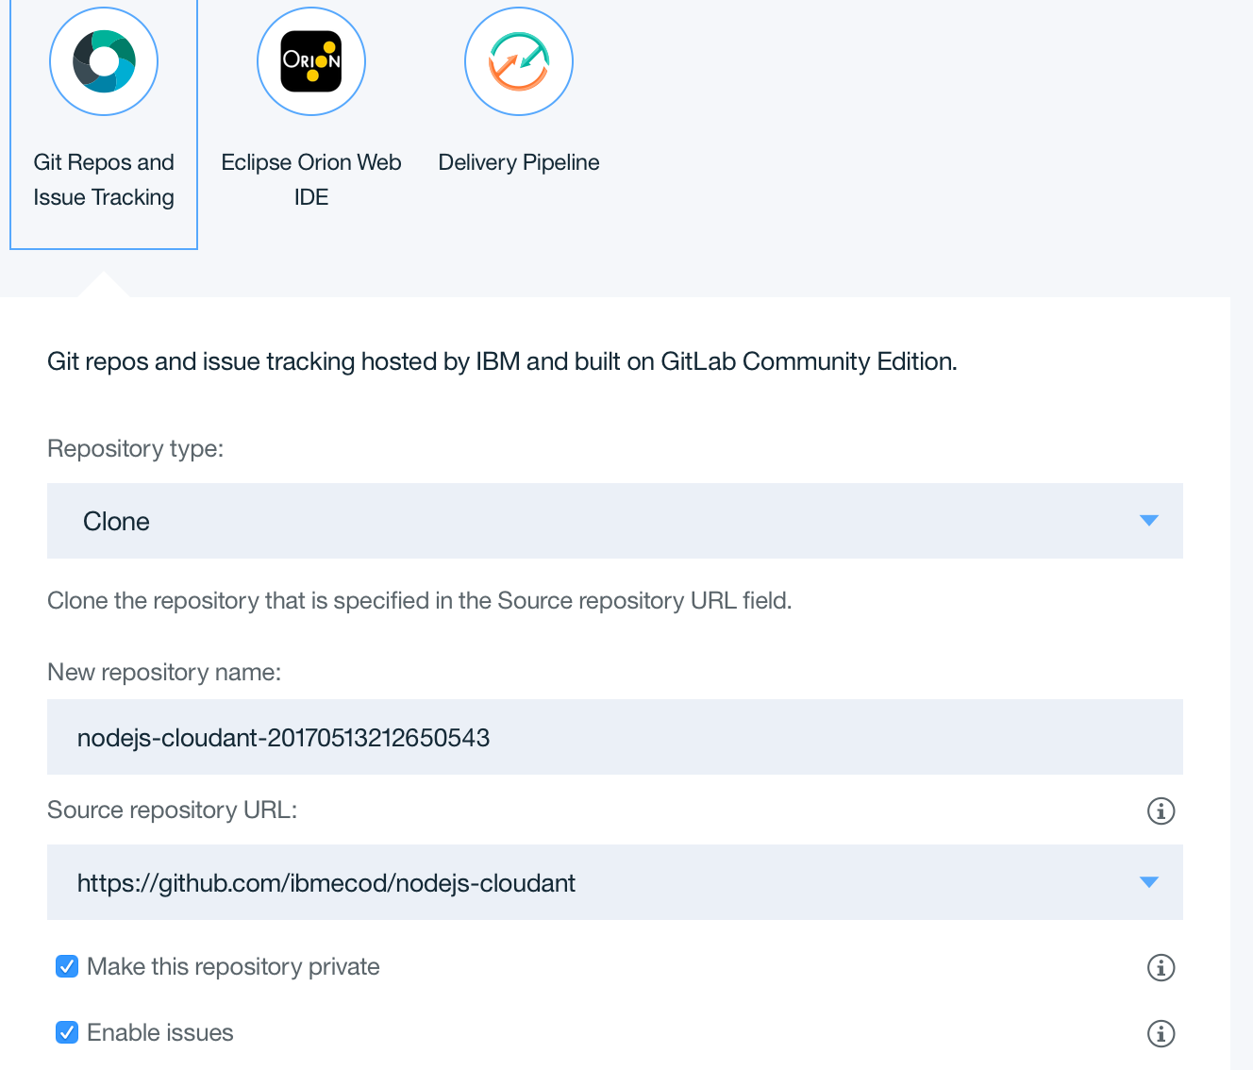

1. Click **“Deploy”**. A confirmation message and a toolchain overview are displayed.

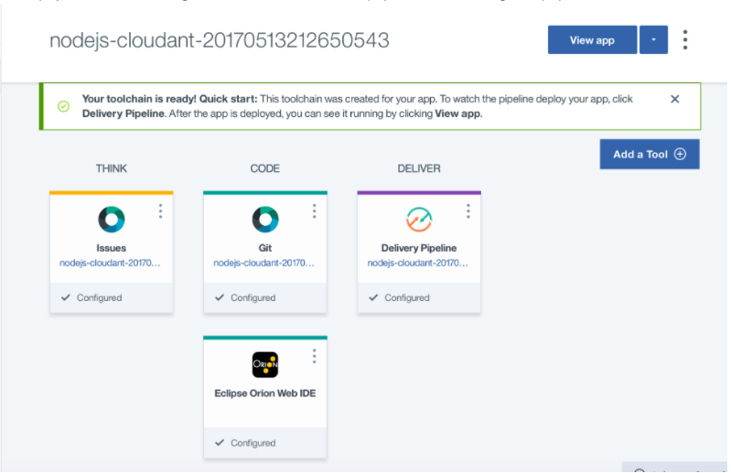

1. Click the **“Delivery Pipeline”** icon to monitor the deployment status. When it finishes, the **“Deploy”** stage will show a successful execution.

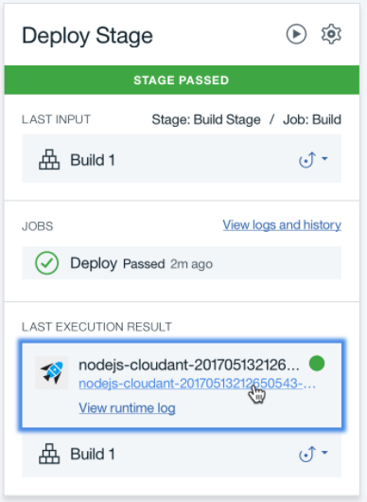

1. Click the link for the app to open it in a new tab. This application is a document and image organizer that uses a Cloudant NoSQL database to store files that are uploaded from a web browser.

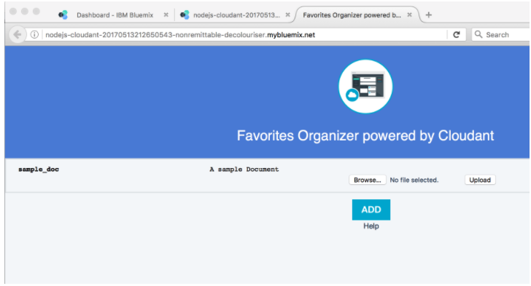

1. The app has been created with a long and random host name. This was chosen based on a property in the manifest.yml file. To change this, navigate back to the application dashboard. Go back to the browser tab with the IBM Cloud dashboard and refresh the page if your new app is not showing. Then, click on the row for the app to open the app dashboard.

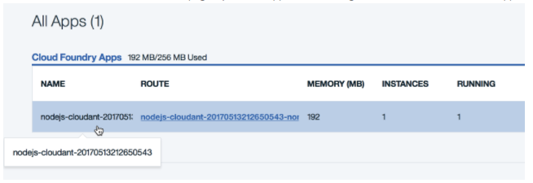

1. Click **“Routes”** and select **“Edit routes”**.

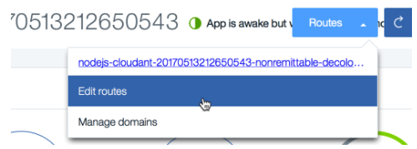

1. Customize the name of the route. For example, call it “secondapp” or “favapp” with your initials and date added to make it unique. Click **“Save”**, and when you are prompted to remove the old route, confirm the removal. The app will take a moment to restart. You can confirm that the new URL is active by clicking the new name from the Routes drop-down menu.

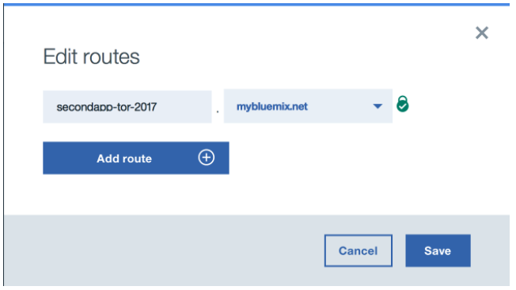

1. When you’re finished experimenting with the app, delete it by clicking the three vertical dots next to the app **STOP** button and selecting **Delete**. Confirm the removal of the database from the **Services** tab and the hostname from the **Routes** tab.

# Conclusion

Now that you have completed this lab, you should be able to:

* Have a basic understanding of cloud computing
* Navigate IBM Cloud Platform
* Launch and use services on IBM Cloud
* Create and manage cloud-native applications using the IBM Cloud UI, as well as locally install tooling